3-4-5 Drug Project

1. Experiments are based on the document entitled “Plate Layout Pinning”. In this document there are 3 different plate templates that were used as the foundation for the experiments. The labels in column A, row 3, and the colored boxes correspond to 3 different source plates layouts that were used for pinning to create all of the final combos listed.
2. Each plate layout listed in the “Plate Layout Pinning” document was replicated 3 times for each combination. Therefore in the raw data folder for each experiment, plates 1-3 correspond to plate layout 1, plate 4-6 correspond to plate layout 2, and plates 7-9 correspond to plate layout 3. If there are more than 9 plates, these correspond to a different 5 drug combination (i.e. plates 10-12 correspond to plate layout 1 for the second combination run on that day).
3. Drug concentrations are also listed in this document under Concentrations tab.
4. To figure out which 5 drug combination was run in each experiment, go to the raw data folder and click on one of the dated runs (i.e. 091916 run). In this folder, there is a document entitled 091916 experiment. This is the template for what was run on that day. Below is an example of what it would look like. In this experimental case, Drug A would be AMP, Drug B would be FOX, Drug C is STR, drug D is DOX, and drug E is TMP (basically the order they appear from left to right). This was how I told the MSSR technician which source plates to pin for what experiment. As you can see by the Xs, plate 1-3 is identical, 4-6 is identical, and 7-9 is identical corresponding to the 3 repeats I discussed earlier.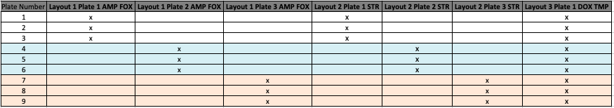
5. The OD readings are in the Raw Data folder for each run.
6. The growth rates calculated and organized using an R program entitled “Growth Rate Program”. You have to make sure your pathways are correct in lines 8, 25, 67, and 72, otherwise the program will not know which files to pull from. The growth rates are calculated using the following steps.
   1. Column A is averaged (this is the negative control) and subtracted from each experimental well and the positive control (last column of the plate on the right)
   2. The slope of each well is calculated using each of the 4 hour intervals for each well using the format below for each individual well. Note, some of the earlier experiments have 20 hour readings, but we discontinued collecting this due to the expected timeframe that the bacteria would undergo exponential growth.

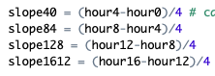

* 1. The far right column (positive control) was averaged.
  2. The maximum slope for each well was determined as well as the maximum average slope of the positive control.
  3. The maximum slope of each experimental well was divided by the maximum average slope of the positive control and multiplied by 100 to give the final growth rate percentage.

1. The growth rate program should output all of the growth rates for each plate into a folder called “Growth Rates”. Although you can change the name of the output in the code if you want.
2. Now that the growth rates were calculated, they needed to be organized in a way that was more easily interpreted. This organization was done using a program called “5DrugCode.R”. Again, it is important to input the proper file pathway. You will also need the rowsToSearch.csv, colsToSearch.csv, and the labels.csv documents. The file pathway must be edited to reflect where they are stored on your computer in lines 19, 20, and 23. This only needs to be done once. The calculated growth rates for each plate must be input in the following manner:

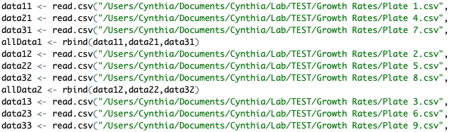

1. If there are more than 9 plates, they would be entered as the following:

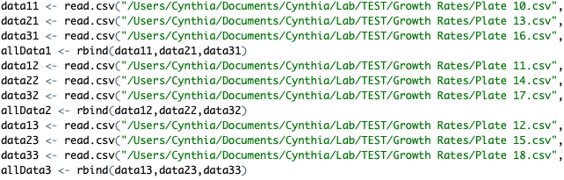

1. This should export a file that is named based on what you put in the last line of the code. It will be labeled drug A, B, C, D, and E. Those drugs will correspond to the drugs determined for the combo in step 4.